1. For the following problem, define an ERD for the initial requirements and then revise the ERD for the new requirements. Your solution should have an initial ERD, a revised ERD, and a list of design decisions for each ERD. In performing your analysis, you may want to follow the approach presented in module 9.

Solution

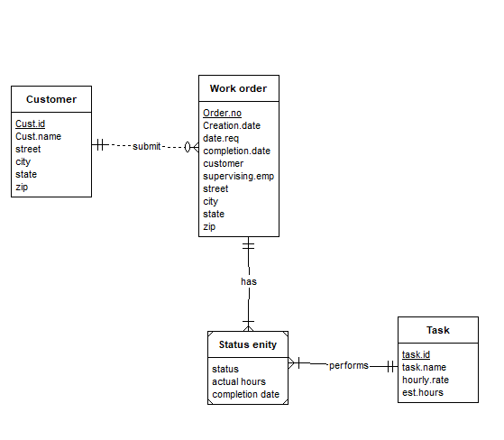

Since each task on work order has a status and is dependent on work order It can be represented as identification dependency with status entity has a weak entity.

After reviewing your initial design, the company decides to revise the requirements. Make a separate ERD to show your refinements. Refine your original ERD to support the following new requirements:

Revised ERD

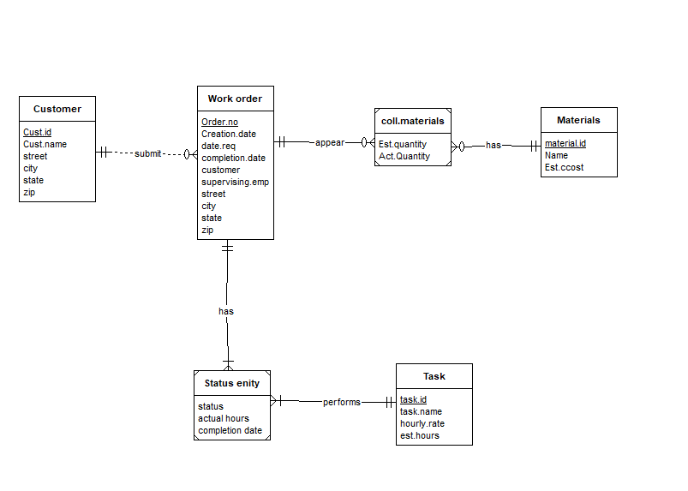

Since Materials used on work order includes Est.quantity and Act.Quantity and it is dependent on Work order it is identification dependency with coll.material as weak entity with identifying relationship